Milestone III
ACC 690

Jeff Carlson

Incorporation
Incorporation is a formal process used in the formation of a company or a corporate entity. An organization's structure is of great importance to running operations and achieving a company's goals (Lee & Kang, 2019). Several considerations, such as whether the business entity will be involved in international trade, are made during the incorporation process (Guillen-Cuevas et al., 2018). Incorporation is also of great importance to the prospective client since it bolsters credibility, attracting even more new customers.
Foreign exchange rates have a significant impact on a company's financial statement that is involved with foreign exchange transactions. These transactions usually involve the purchasing and selling of foreign currency (Shamsudin, 2017). Various economic theories support that consistent changes in foreign exchange rates have a significant direct impact that causes a shift in stock prices. This is mainly evident amongst multinational companies and import and export firms. The effect of exchange on such components of the financial statement calls for special treatment of these variables when making financial statements (Robinson, 2020). Therefore, a business entity is expected to follow the guidelines of the international accounting standards (IAS 21) on how to treat and translate its financial statement into a presentation currency.
Also, the foreign exchange rate poses a threat to the operation of a given company. These threats are the risk taken when doing an international transaction or if a given entity keeps its financial statement in a different currency from where it is headquartered (Gebska, 2020). This risk also affects both the existing and prospective investors of a company since they significantly affect the company's dividends and share prices. This risk can be subdivided into transaction risk, economic risk, and translation risk. Translation risks are the risk encountered by a company that conducting business outside the country it is headquartered but denotes its financial performance in the domestic currency. Economic risk is the forecast risk that affects the company's market value due to fluctuations in exchange rates (Alagidele & Ibrahim, 2017). On the other hand, transaction risk is the risk encountered by a company that makes the international financial transaction caused by time delay.
Companies that trade in foreign currency are usually required to translate the currencies to their jurisdiction (Natalie, 2017). The companies should follow a given consistent translation method as per the international accounting standards to ensure an accurate reflection of the prevailing economic circumstances. The current / non-current and the monetary-nonmonetary translation are the two main methods used. The current / non-current method converts the values of current assets and liabilities using the prevailing exchange rate as per the date of the balance sheet. On the other hand, non-current liabilities and assets are converted using the historical rates (Chen & Zhao, 2019). The monetary-nonmonetary method is employed when a foreign subsidiary is significantly integrated with its mother company. It aims at representing the translated amount as export from the mother company.
The functional currency is an important determinant of the method employed to translate financial statements (Fernandez et al., 2020). This currency is the main means of payment to the company and is mostly the headquarter nation's currency.
A hypothetical example showing the translation process using the two methods
Suppose that Bissvent limited is a European subsidiary of the United States company.
The current / non-current
Consider the balance sheet below taking the historical exchange rates as €1= $1.20 and the current rate as €1=$ 1.15
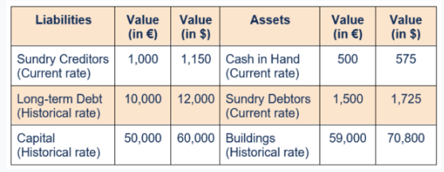
The Monetary-Nonmonetary Method
In this case, the balance sheet is prepared using the monetary-nonmonetary method
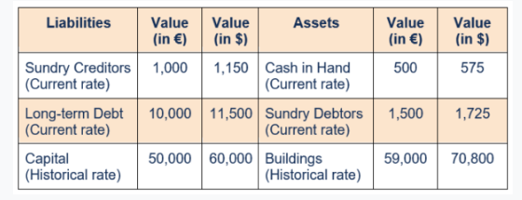

References
Alagidede, P., & Ibrahim, M. (2017). On the causes and effects of exchange rate volatility on economic growth: Evidence from Ghana. Journal of African Business, 18(2), 169-193.
CHEN, G., & ZHAO, W. D. (2019). A Comparative Study of the Application of Temporal Method and Current Rate Method. DEStech Transactions on Computer Science and Engineering, (cmso).
Fernández, J., Pino, F., & Vásquez, F. (2020). Corporate-Sector Functional Currency: An International Comparison (No. 882). Central Bank of Chile.
Gębska, M. (2020). Globalization in Growing Financial Markets as a Threat to the Financial Security of the Global Economy.
Guillen-Cuevas, K., Ortiz-Espinoza, A. P., Ozinan, E., Jiménez-Gutiérrez, A., Kazantzis, N. K., & El-Halwagi, M. M. (2018). Incorporation of safety and sustainability in conceptual design via a return on investment metric. ACS Sustainable Chemistry & Engineering, 6(1), 1411-1416.
Lee, I. S., & Kang, I. W. (2019). A Study on the Effect of Corporate Social Responsibility on Organizational Commitment, Organizational Trust, Organizational Citizenship Behavior: Focusing on Incorporation Companies in Business Incubator. Asia-Pacific Journal of Business Venturing and Entrepreneurship, 14(2), 235-247.
Natalie Tatiana Churyk Ph.D., C. P. A. (2017). Foreign Currency Translation and Consolidation: A Case Study. Global Perspectives on Accounting Education, 14, 1-9.
Robinson, T. R. (2020). International financial statement analysis. John Wiley & Sons.
SHAMSUDIN, M. Y. H. (2017). SHARIʻAH COMPLIANCE OF FOREIGN EXCHANGE TRANSACTIONS IN THE ISLAMIC BANKING INSTITUTIONS.

